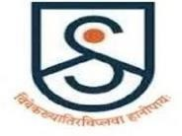

SIKKIM ALPINE UNIVERSITY

Report on Animal Birth Control Sterilization Drive

Sikkim Alpine University, in collaboration with the Sikkim Anti-Rabies and Animal Health (SARAH) Division and the Department of Animal Husbandry and Veterinary Services, Government of Sikkim, recently conducted a successful Animal Birth Control (ABC) sterilization drive aimed at the safe and effective management of the stray dog population on campus.

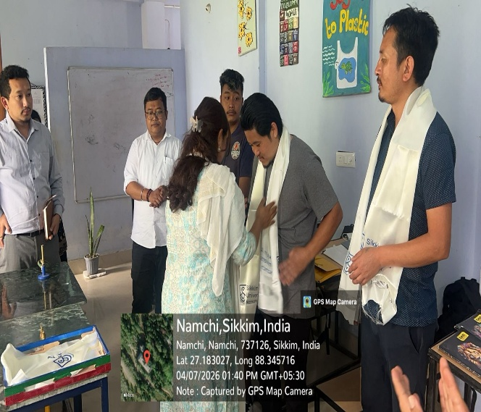
Upon their arrival, the visiting SARAH team was accorded a warm and traditional welcome. As a gesture of respect and hospitality, traditional khadas were offered by Ms. Pema Tamang, Nodal Officer for the State Stray Dogs and Rabies Control Act under the Department of Animal Husbandry and Veterinary Services. Mr. Hissey Dorjee Bhutia, Veterinary Aid, SARAH, highlighted the importance of organising future awareness campaigns focusing on stray dog vaccination and precautionary measures.

Stray dogs residing within the university premises were carefully identified and humanely secured. All identified canines were subsequently enrolled in the ABC programme. The animals are undergoing sterilisation procedures under the supervision of qualified veterinary doctors and will be safely returned to the campus following a recovery period of approximately two days.

The sterilisation drive was undertaken as a proactive measure to regulate the stray canine population, reduce the risk of rabies transmission, and promote a safer and healthier campus environment. The success of this initiative was made possible through the effective coordination and cooperation between SARAH personnel and the dedicated support staff of the university.
